📍 Property Access Guide
2425 Wilbur Ave, San Diego, CA

🗺️ Property Location (Aerial View)
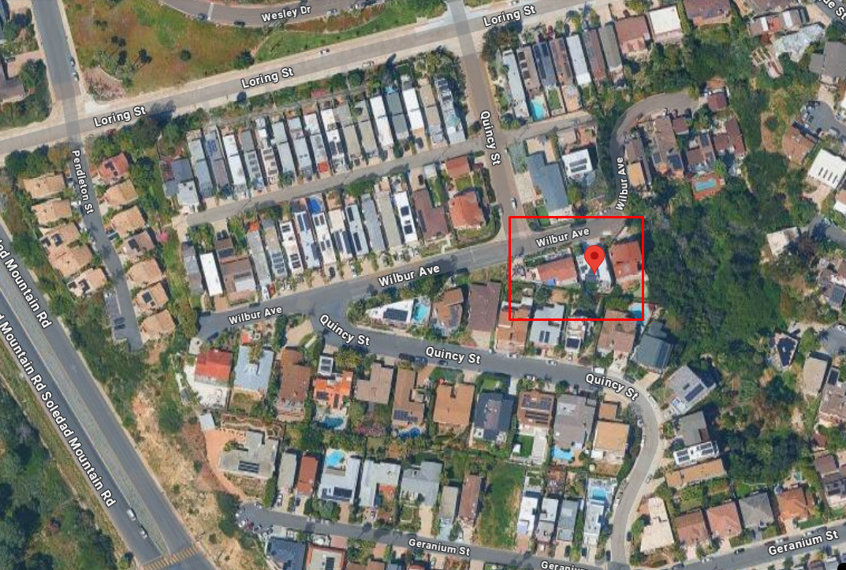
🧭 Driving Directions
🚗 From Soledad Mountain Road (Main Approach)
Head east on Loring St from Soledad Mountain Rd
Continue straight for about 0.5 miles
Turn right onto Quincy St
After a short drive, turn left onto Wilbur Ave
Continue for about 200–300 feet
The home will be on your right-hand side

🚗 From San Joaquin Dr
Head toward Aster St
Turn onto Aster St
Drive straight, then turn left onto Randall St
Turn right onto Wilbur Ave
Continue a short distance
The property will be on your left-hand side

📍 Final Arrival Tip
Use GPS: “2425 Wilbur Ave, San Diego, CA”
Look for a modern white home with a driveway and front stairs leading to a glass entry door
If you reach the curve of Wilbur Ave, you’ve gone slightly past it, just turn around
🏡 Property Overview

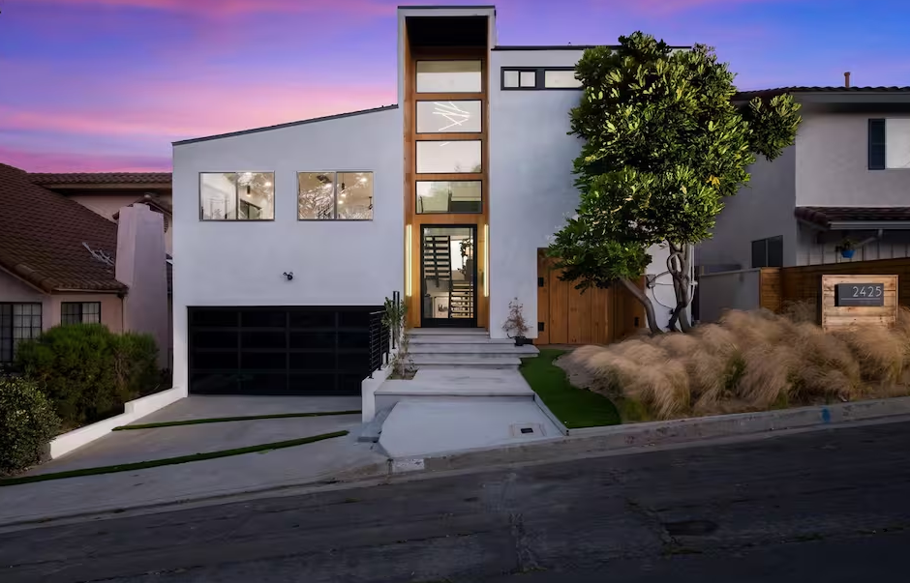

Welcome to your San Diego stay!
Everything you need for a perfect stay — beautifully organized.

What to look for upon arrival:

- White contemporary home design
- Driveway and garage on the left side
- Trash bins typically lined along the driveway
- Main entrance accessed via front stairs (not street-level)

⚠️ Note:

- The home sits slightly elevated from the street, so you’ll need to walk up a short set of stairs to reach the front door.
- Use caution when walking up/down the stairs, especially at night
- Respect neighbors by keeping noise levels low during quiet hours

🚗 Parking Instructions

Driveway Parking
- The driveway is available for guest use
- Please park fully within the driveway and avoid blocking the sidewalk

Street Parking (If Needed)
- Street parking can be limited but usually manageable
- You may need to park a few blocks away

Important Rules:
- Follow the 72-hour parking rule
- Observe street sweeping schedules
- Do NOT park within 20 feet of crosswalks

🔑 How to Open the Front Door
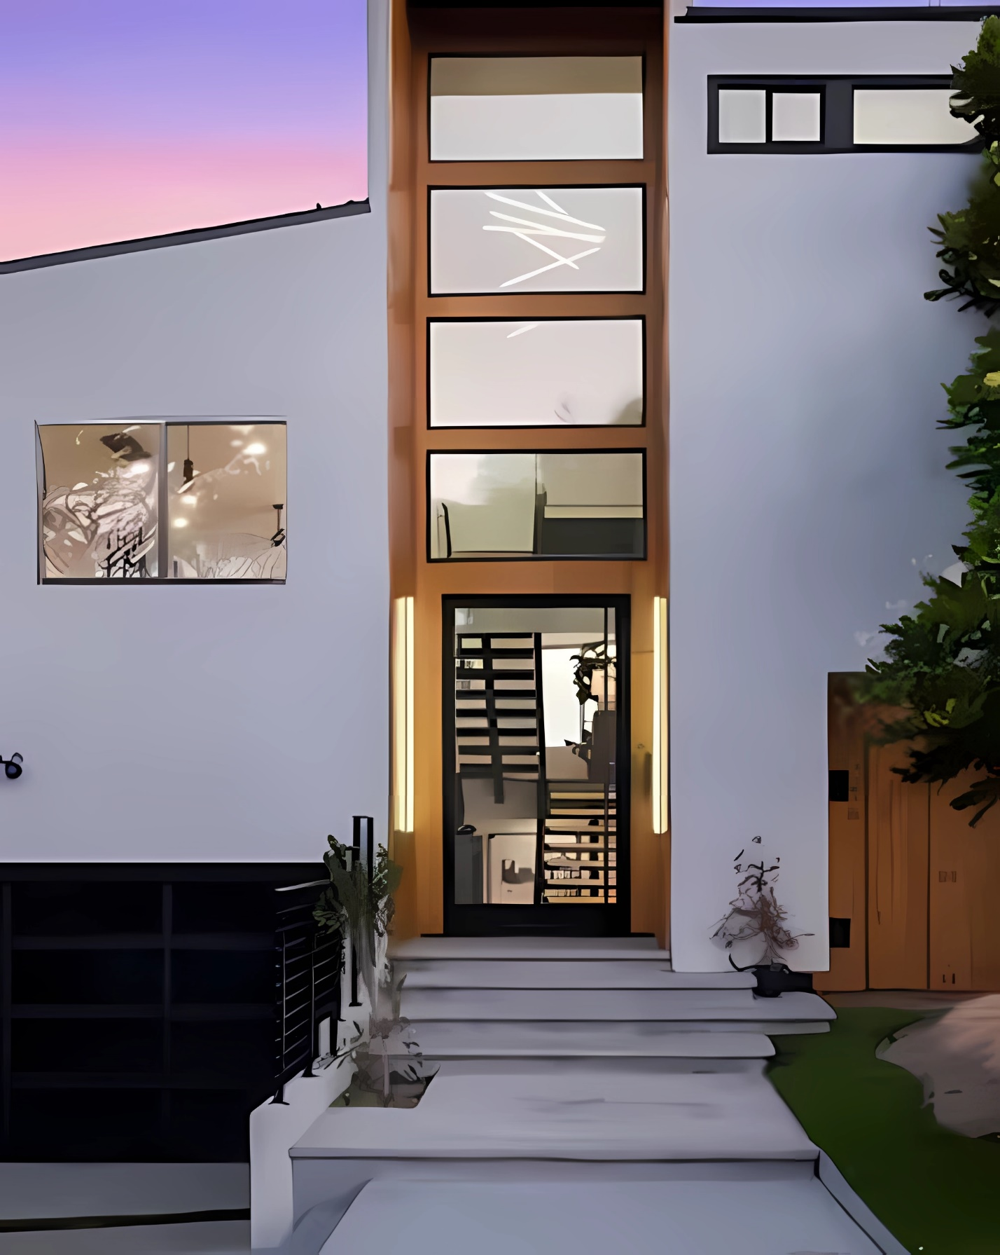

.

🚪 Step-by-Step Entry Instructions

- Wake the (SCHLAGE) Keypad
- Tap the screen or press any button to activate the keypad
- Enter Your Access Code
- Carefully input your personalized access code
>> Your code will be provided to you one day before your arrival
- Wait for the ✔️Signal
- Gently push the door to enter

⚠️ If the Door Doesn’t Unlock

- Double-check the code and re-enter slowly
- Ensure you pressed the confirm/unlock button
- Wait a few seconds before trying again

📶 WiFi Access
Network: SpectrumSetup-B7FA
Password: formerworld153
Note: The password is case-sensitive.

📍 The WiFi router is located in the living room

🔧 Quick Troubleshooting Tips
If you’re having trouble connecting:
✔️ Double-check the network name and password
✔️ Make sure WiFi is turned on in your device
✔️ Move closer to the living room for a stronger signal
✔️ Turn WiFi off and back on
✔️ Restart your device

🔌 Restarting the Router (If Needed)
If the connection is still slow or not working:
✔️ Locate the router in the living room
✔️ Unplug the power cable
✔️ Wait 30–60 seconds
✔️ Plug it back in
✔️ Wait 2–3 minutes for the internet to fully reconnect

🎒 What to Bring (Quick Tips)
We’ve got the basics covered, but here are a few things guests usually appreciate bringing:
- Your favorite toiletries (we provide a starter set including:
- Toiletries (starter set)
- Paper towels
- Bath tissue
👉 For longer stays or personal preferences, you may want to bring extras.
- Phone chargers & devices
- Camera (the views are worth it!)

🍔 Food Delivery Made Easy
Staying in? You can have food delivered right to your door!
Uber Eats or DoorDash:
Open the app or website
Enter the address: 2425 Wilbur Ave, San Diego
Choose your food
Place your order and track it in real time
Helpful Tips:
Keep your phone nearby for driver updates
Add notes like “Front door is up the stairs”
Order early during busy hours

⏳ Suggestions if You Arrive Early
If you arrive before check-in time, here are a few easy ways to enjoy your time:
☕ Better Buzz Coffee Roasters
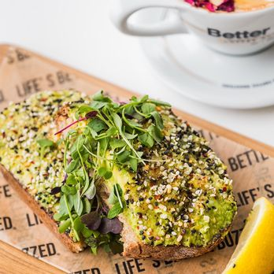
📍 Address: 1909 Garnet Ave, San Diego, CA
🚗 Distance: ~5 minutes (1.5 miles)
- Great coffee, smoothies, and breakfast
- Popular for their avocado toast

🌮 Oscars Mexican Seafood

📍 Address: 746 Emerald St, San Diego, CA
🚗 Distance: ~6 minutes (1.7 miles)
A must-try local favorite, Known for fresh fish tacos!

🍔 The Baked Bear
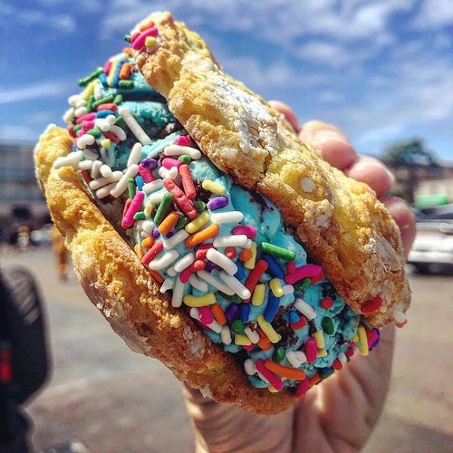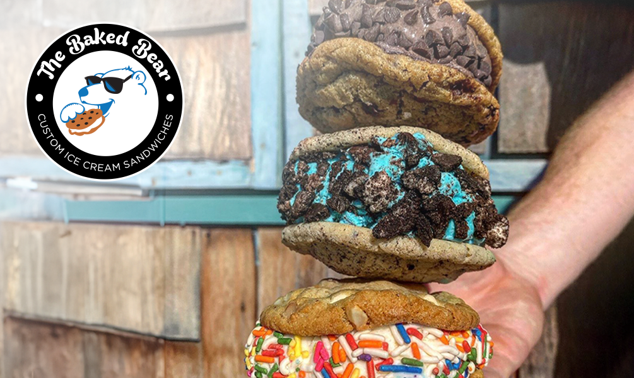

📍 Address: 4516 Mission Blvd, San Diego, CA
🚗 Distance: ~7 minutes (2.0 miles)
Sweet treat spot 🍦
- Build-your-own ice cream sandwiches
- Perfect after dinner or a beach day

 Trash Bin Management
 Collection Schedule
Trash: Monday
Recycling: Monday
 Before Collection Day
Please place all trash and recycling in the appropriate bins
Ensure lids are fully closed to prevent odors and animals
Avoid overfilling bins
 Recycling Guidelines
Only place approved recyclable items (clean paper, cardboard, plastics, cans)
Do not include food waste or contaminated items
 Important Notes
Do not leave trash bags outside bins (this may attract animals)
If bins are full, please avoid forcing additional trash, reach out for
assistance if needed

Medical & Emergency Information
🚨 For police, fire, or medical emergencies — Call 911 immediately
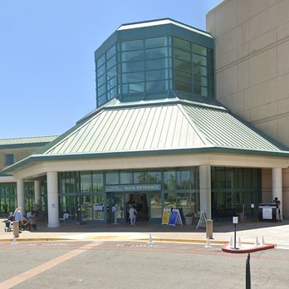
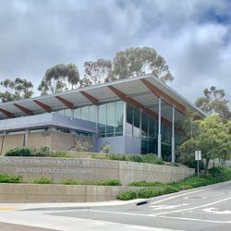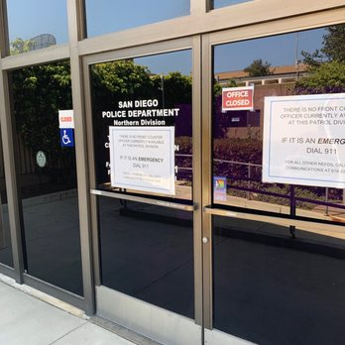

🏥 UC San Diego Health — La Jolla
Nearest Hospital (Non-Emergency)
📍 9300 Campus Point Dr, La Jolla, CA 92037
📞 (858) 657-7000

👮‍♂️ San Diego Police Department — Northern Division
📍 13396 Salmon River Rd, San Diego, CA 92129
📞 (858) 538-8000
For non-emergency police assistance

